21st century 800 mcg folic acid tablets, Assorted 180 Count

95.10

21st century acidophilus capsules, 100 Count 177.59

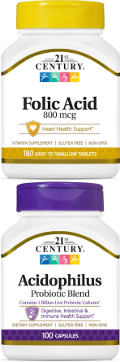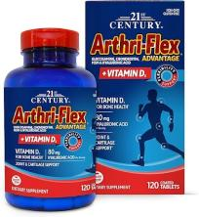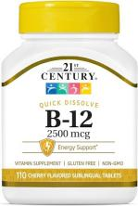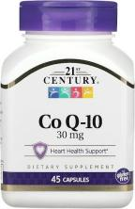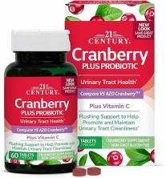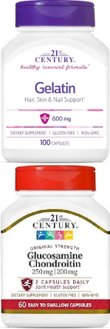

21st arthric -flex Advantage Plus vitamin D3 joint support supplement (120 Tablets)

# 444.85

21st century B12 2500mcg sublingual tablets, 110 Count

177.59

21st century CoQ10 30 mg capsules, 45 Count 222.55

21st century cranberry plus probiotic tablet, 60 Count

199.82

21st century Gelatine 600mg dietary supplement (100 Count)

172.65

21st century glucosamine chondroitin 250/200mg original strength, 60 Countt

207.73

21st century hair, skin and nails extra strength tablets ,90 count

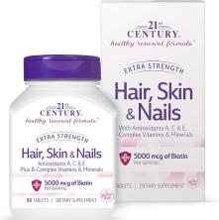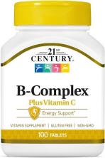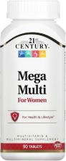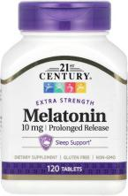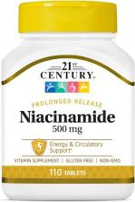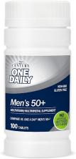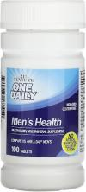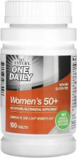

# 223.04

21st century healthcare, B complex plus vitamin C, tablet100count

# 207.48

21st century mega multi for woman tablets 90count

266.51

21st century melatonin 500mg prolonged release, 120 count

217.61

21st century niacinamide 500mg prolong release tablets, 110 count

111.89

21st century one daily men’s 50+tablets ,100count 222.05

# 21st century one a daily men’s health tablets ,100count.147.95

21st century one daily women 50+ tablets, 100 count 222.05

21st century one daily woman’s tablets, 100count 147.95

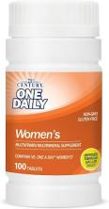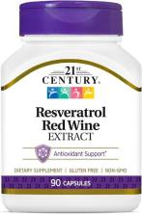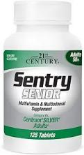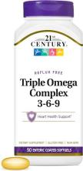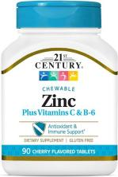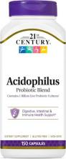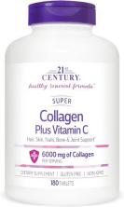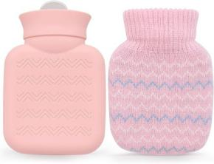

21st century resveratrol red wine extract capsule ,90 count 195.38

21st century sentry senior tablets ,125 counts 152.89

21st century vitamins enteric coated triple omega complex 3-6-9, reflux free 90 soft gels

# 246.75

21st century zinc chewable with vitamin C & b6 -cherry 90 count

# 234.40

21st century, Acidophilus probiotic blend, 150 capsules

222.79

21st century, super collagen plus vitamin c 6000mg 180 tablets 353.95

320ml hot water bottle with knitted cover 246.75

Advil liquid-gel pain reliever and fever reducer, Ibuprofen 200mg capsules 240ct

Advil pain reliever and fever reducer, Ibuprofen 200mg capsules 24ct

Advil liqui-gel pain reliever and fever reducer, Ibuprofen 200mg capsules 10ct

Advil PM pain reliever and nighttime sleep aid, Ibuprofen sleep aid -120 coated caplets

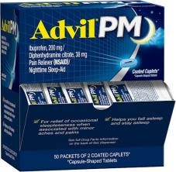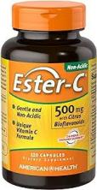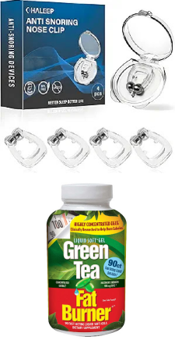

518.21

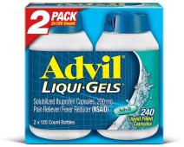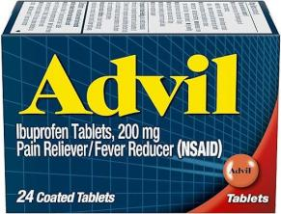122.76

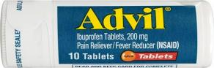76.32

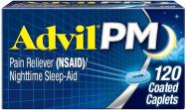320.85

Advil pm pain reliever and nighttime sleep aid ,50x 2 coated caplets

# 406.07

American health Ester -c with citrus bioflavonoids capsules -gentle on stomach, non-acidic vitamin c-500mg ,60 servings, 120 count

Anti snoring devices, snore stopper with adjustable magnet, silicone nose clip stop snoring, 4 count

Applied nutrition green tea weight loss supplement, 90count capsules

375.19

229.96

# 246.01

Arm & Hammer simply saline daily care nasal

152.15

Azo cranberry urinary tract health supplement ,100 soft gels

298.87

Azo cranberry urinary tract health gummies dietary supplement ,72 count gummies

296.15

Azo urinary pain relief maximum strength, 99.5mg ,24 tablets

199.82

Benadryl allergy plus congestion ultra tabs 24 ct 180.06

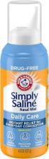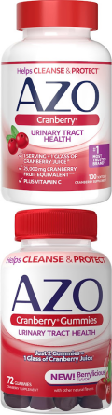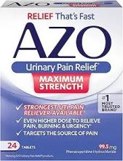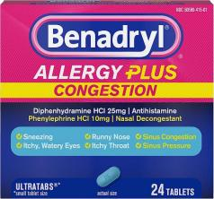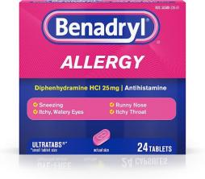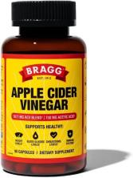

Benadryl ultra tabs antihistamine allergy relief with diphenhydramine hcl ,24ct

# 147.71

Bragg apple cider vinegar capsules -750mg of acetic acid -immune & weight management support -90ct

Care all hydrocortisone 1%,1oz tube, maximum strength anti-itch cream

# 374.45

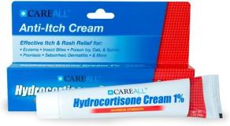45.20

Centrum adult multivitamin/multimineral supplement with antioxidants -200ct

# 348.76

Centrum kid’s multivitamin gummies, stocking stuffer, tropical punch Flavors made with natural flavors,150ct ,150 days’ supply

Centrum multivitamin for men ,100ct

380.87

258.86

Centrum multivitamin for women -100ct 258.86

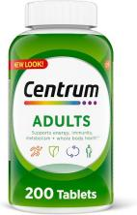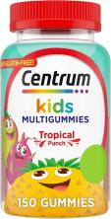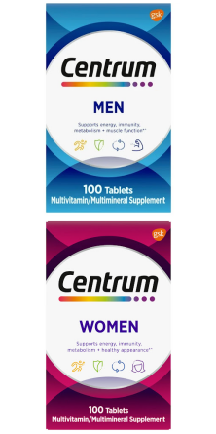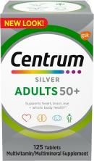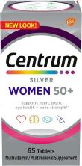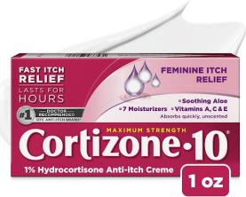

Centrum silver adults 50+ multivitamin tablet 125ct

278.12

Centrum silver women’s 50+ multivitamin 65ct

190.68

Cortizone 10 maximum strength feminine itch cream ,1% hydrocortisone,1oz

120.78

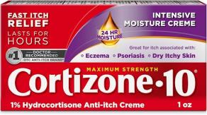Cortizone 10 maximum strength intensive moisture anti-itch cream, 1% hydrocortisone ,1oz

123.25

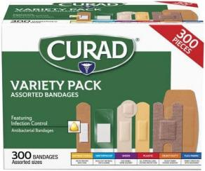Curad Assorted bandages including antibacterial, heavy duty, fabric, and waterproof bandages ,300pieces

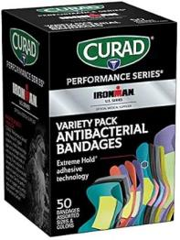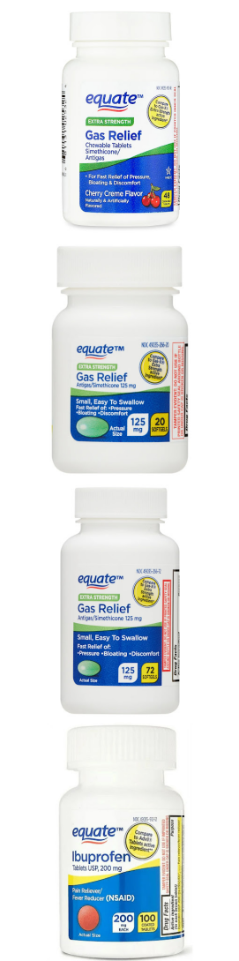

Curad performance series ironman antibacterial bandages 50 count

300.85

172.16

Equate extra strength gas relief chewable tablets, cherry creme ,48ct

# 147.71

Equate extra strength gas relief simethicone 125mg soft gels ,20ct

33.10

Equate extra strength gas relief simethicone 125mg soft gels ,72 ct

98.31

Equate ibuprofen pain reliever and fever reducer coated tablets,200mg ,10048.91

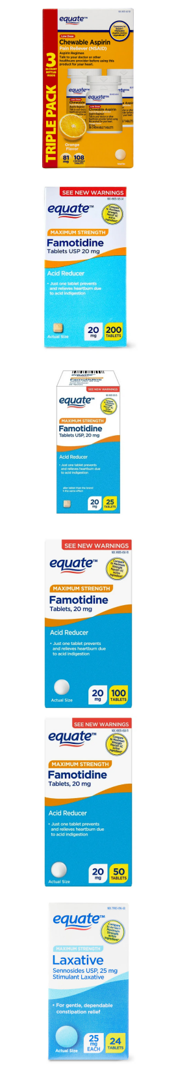Equate low dose chewable aspirin 81mg tablets, orange Flavors ,3x36 ct

Equate maximum strength famotidine tablets,20mg ,200ct

Equate maximum strength famotidine tablets,20mg ,25ct

Equate maximum strength famotidine tablets,20mg ,100ct

Equate maximum strength famotidine tablets,20mg ,50 ct

Equate maximum strength sennosides laxative tablets,25mg ,24 ct

# 71.14

310.48

77.81

# 209.46

127.13

73.61

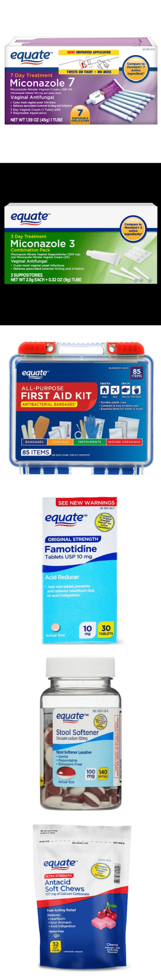Equate miconazole 7-day vaginal cream with disposable applicators ,1.59oz

Equate miconazole nitrate vaginal suppositories (200mg) & miconazole nitrate (2%), comb pack

Equate on-the-go first aid kit-home, travel, office, auto, school,85pieces

Equate original strength famotidine tablets,10mg ,30 CT

Equate stool softener laxative soft gels for constipation ,100mg ,140ct

Equate ultra strength antacid soft chews for heartburn and indigestion relief, cherry,32soft chews

# 147.46

172.16

186.73

98.31

# 112.14

82.50

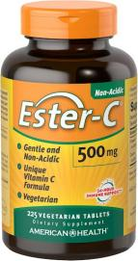Ester-c vitamin c 500mg coated tablets ,225 count

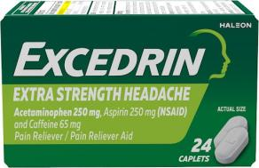Excedrin extra strength caplets for headache pain relief,250mg acetaminophen, aspirin 250mg, caffeine 65mg ,24ct

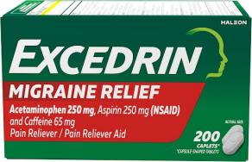Excedrin migraine relief caplets 200 count

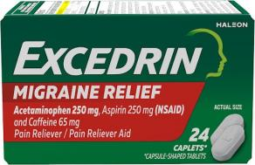Excedrin migraine relief caplets 24 count

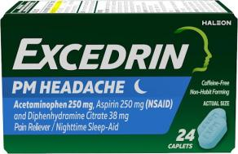Excedrin PM pain reliever and nighttime sleep-aid caplet 24 counts

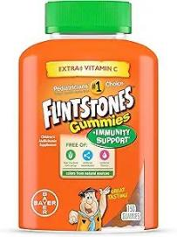Flintstone gummies kid’s vitamins with immunity support*, orange 150 count

# 515.49

122.76

# 412.24.

122.76

147.95

# 324.81

Force factor probioslim apple cider vinegar gummies with organic lactospore probiotics and prebiotics ,60 gummies

290.23

Garlique garlic extract supplement, healthy cholesterol formula, cholesterol support,5000mcg allicin,60 caplets

298.13

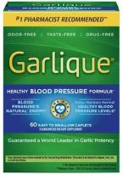Garlique healthy blood pressure support supplement, Odor free garlic,1800mcg allicin,60ct

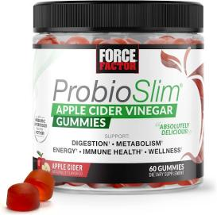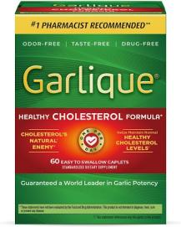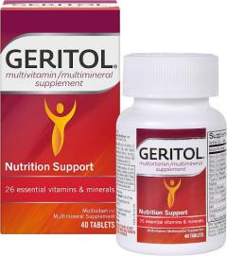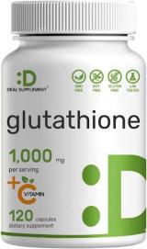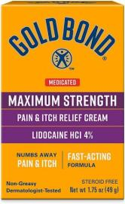

Geritol, multivitamin supplement contains B-vitamins, antioxidants,40 tablets

295.66

# 165.74

Deal supplement glutathione supplement 1000mg per serving,98% purity| plus vit C500mg ,120count

# 538.34

Gold Bond medicated maximum strength pain & itch relief cream,1.75 oz

# 193.40

Goli Nutrition apple cider vinegar gummies ,60 CT

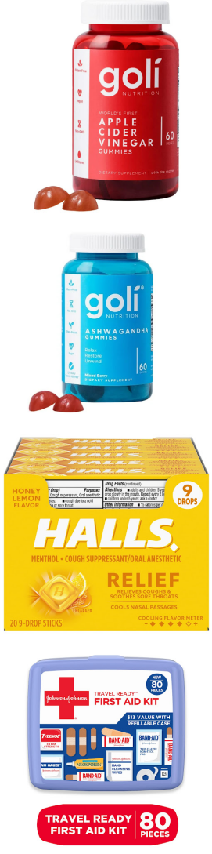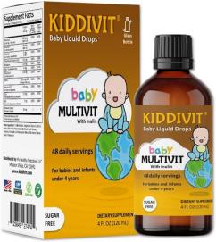

370.01

Goli nutrition ashwagandha gummies, mixed berry Flavors 60 CT

370.01

Halls relief honey lemon cough drops, 20 Packs of 9 Drops

# 644.18

Johnson & Johnson travel ready portable emergency first aid kit, 80 pc

# 246.51

Kiddivit baby multivitamin liquid with inulin -48 daily servings ,4Fl oz (120ml)

# 444.35

L’il critters gummy Vites daily gummy multivitamin for kids , 70 Gummies

# 145.24

L’il Critters gummy Vites daily gummy multivitamin for Kids 190 Gummies

278.86

L’il Critters paw patrol gummy Vites, 60 Gummies 145.24

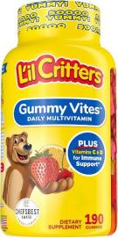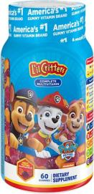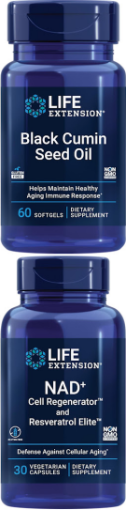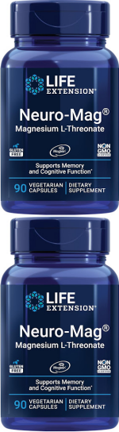

Life extension black cumin seed oil, black cumin, immune health support, whole-body health, healthy aging, gluten free, non-GMO,60 soft gels

220.57

Life extension NAD+ Cell regenerator and resveratrol elite ,30 vegetarian capsule

823.99

Life extension Neuro-mag Magnesium L-threonate, Magtein, Magnesium supplement ,90 vegetarian capsules

# 646.89

Life extension Neuro-mag Magnesium L-threonate, Magtein, Magnesium supplement ,90 vegetarian capsules

# 646.89

Life extension vitamin B3 Niacin 500mg -Niacin ,100 capsules

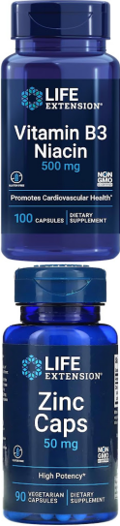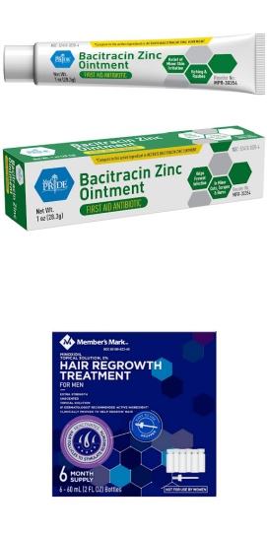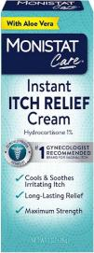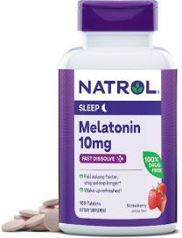

182.78

Life extension zinc 50 mg citrate 90 count

221.81

MED Pride bacitracin zinc ointment, relief for chaffing, diaper rash, dermatitis, eczema, itchy /dry skin| 1oz tube

# 42.73

Member’s mark minoxidil 5%, hair regrowth treatment for men, 2oz .6ct

# 493.51

Monistat instant itch relief cream for women, maximum strength feminine itch care ,1oz

123.50

Natrol fast dissolve melatonin 10mg ,100 strawberry-flavoured melatonin tablets

325.79

Natrol melatonin gummies, sleep support for adults, 10 mg melatonin, 90 strawberry-flavoured

271.21

Nature made burp-less ultra-Omega-3 fish oil soft gels, 1400mg 130ct

635.53

Nature made cholestoff plus soft gel 210ct 629.36

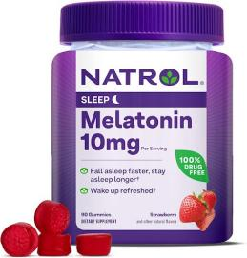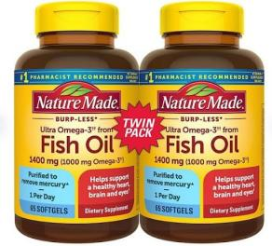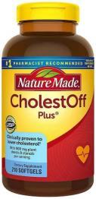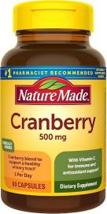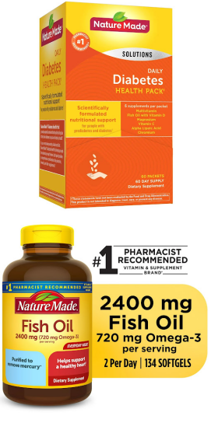

Nature made cranberry supplement 500mg with vitamin C for immune & antioxidant support, day 60capsules

296.15

Nature made daily diabetes health pack dietary supplement tablets ,60ct

582.23

Nature made fish oil 2400mg, omega 3 fish oil supplements,134ct

335.18

Nature made flaxseed oil 1000mg fish free omega 3 supplement, 100 soft gels

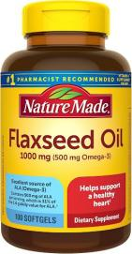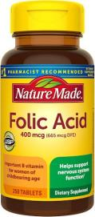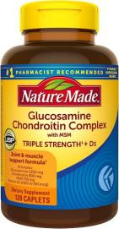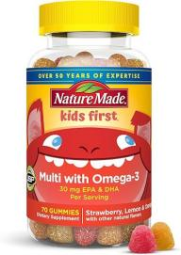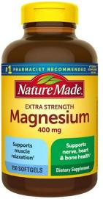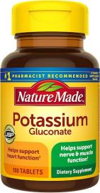

185.00

Nature made folic acid 400mcg (665mcg DFE)250tablets

171.17

Nature made glucosamine chondroitin complex with MSM,for joint support,120 caplets 60 Day Supply

382.85

Nature made kids first multivitamin with omega-3, 70 multivitamin gummies

# 242.55

Nature made magnesium oxide 400mg softgels 150ct f

357.66

Nature made potassium gluconate 550 mg, 100 Tablets

93.12

Nature made super b complex with vitamin c and folic acid ,140 tablets

# 239.34

Nature made triple omega 369 softgels, dietary supplement, 170 counts

# 493.51

Nature made triple omega 3,6,9,74 soft gels 295.91

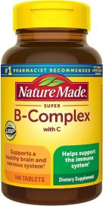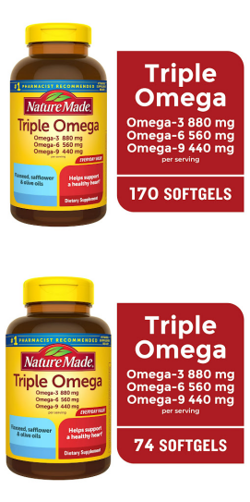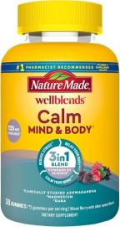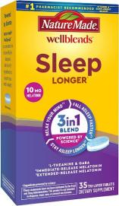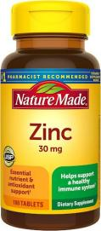

Nature made well blends calm mind & body, magnesium citrate, ashwagandha 123mg & GABA 100mg, 38 gummy vitamins.

320.85

Nature made well blends sleep longer , melatonin 10mg, L theanine 100mg and GABA 100mg ,35 tri-layer

276.15

Nature made zinc 30 mg 100mg tablets - 123.25

Nature’s bounty 1000mg berberine herbal health capsule 60 capsules

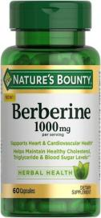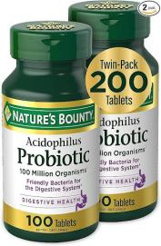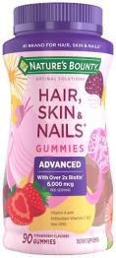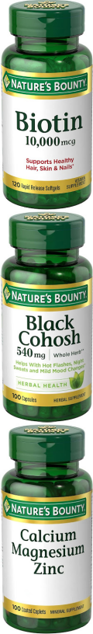

# 444.35

Nature’s bounty acidophilus probiotic ,twin pack 200 tablets

298.38

Nature’s bounty advanced hair, skin, and nails gummies, biotin 6000mcg, vitamin a, c, and e, strawberry, 90ct

233.66

Nature’s bounty biotin, supports healthy hair, skin and nails, 10,000mcg, rapid release soft gels ,120ct

# 224.28

Nature’s bounty black cohosh root pills, natural menopausal support, 540mg, 100 capsules.

153.88

Nature’s bounty calcium magnesium & zinc caplets, immune & supporting bone health, 100counts

170.68

Nature’s bounty CoQ10 200mg softgels, heart health & cellular energy support 80 rapid release softgels

# 419.65

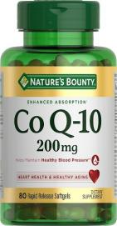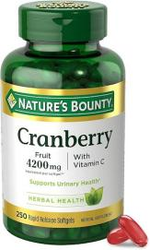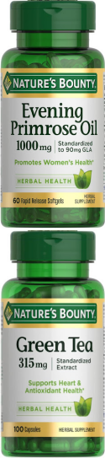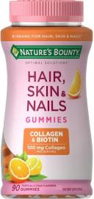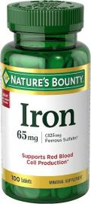

NaTure’s bounty Cranberry 4200mg with vitamin C urinary health & immune support, cranberry concentrate, 250 rapid release soft gels

365.07

Nature’s bounty Evening primrose oil, 1000mg,60 rapid release softgels

215.38

Nature’s bounty green tea pills and herbal health supplement, support heart and antioxidant health ,315mg ,100capsules

198.59

Nature’s bounty hair skin and nails with collagen and biotin, gummies ,90ct

209.95

Nature’s bounty Iron 65mg ,325mg ferrous sulfate ,100 tablets

# 134.62

Nature’s bounty Magnesium Glycinate 240mg supplement capsules 180ct .

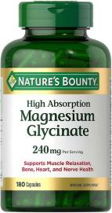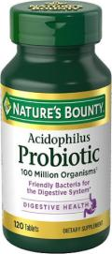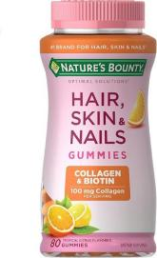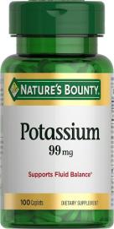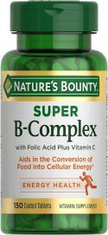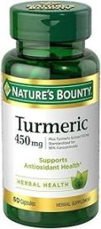

# 481.16

Nature’s bounty Probiotics dietary supplement ,120 tablets

195.13

Nature’s bounty Optimal solution hair, skin & nails 2500mcg ,80ct

209.95

Nature’s bounty potassium, dietary supplement,99mg, 100caplets

# 109.42

Natures’ bounty super B complex with vitamin C & folic acid, immune & energy support, 150 tablets.

# 240.83

Nature’s bounty turmeric capsules, antioxidant health, 450mg ,60ct

207.23

Nature’s bounty with black pepper extract, supports antioxidant health,1000mg ,60cap.

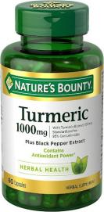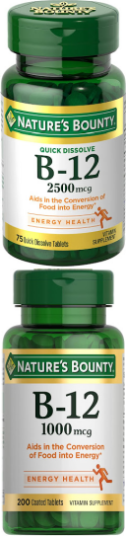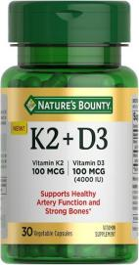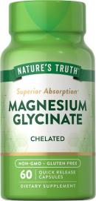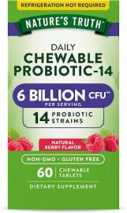

292.70

Nature’s bounty vitamin b12 2500mcg, cellular energy support, for energy metabolism, heart & nervous system health, 75quick dissolve tablets

# 210.44

Nature’s bounty vitamin B12, supports energy metabolism, tablets 1000mcg 200ct.

270.96

Nature’s bounty vitamin D3 K2 supplement,4000lU vitamin D3 plus 100mcg of vitamin K, 30-day supply 30 vegetarian capsules.

# 164.26

Nature’s truth magnesium Glycinate Capsules 200mg ,60counts

258.12

Nature’s truth probiotic chewable for Men and Women /6 billion CFU/60count/14 strains

238.36

Nature’s truth probiotics for women/5 billion CFUs daily /40 vegetarian capsules

# 246.75

Neilmed Sinus rinse -a complete sinus nasal rinse kit, 50 count (pack of 1 )

283.56

Neilmed Sinus rinse all natural Relief Premixed refill packets 100 count

382.60

Neocell super collagen tablets with vitamin C and Biotin , 90 count

266.27

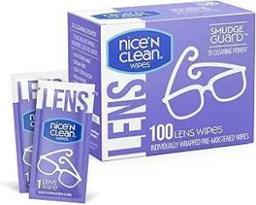Nice ‘n Clean smudge Guard lens cleaning wipes (100 total wipes )

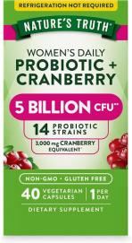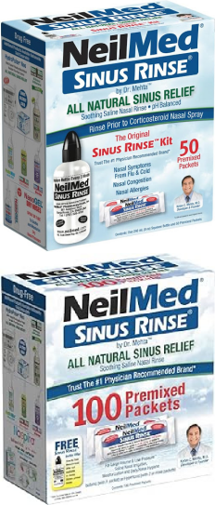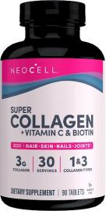

# 172.41

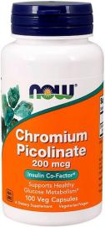NOW Chromium Picolinate 200mcg ,100 capsules 160.55

NOW foods inositol 500mg , 100 capsules 208.96

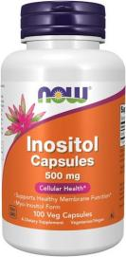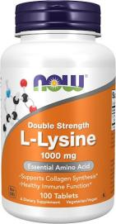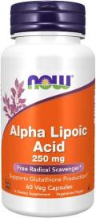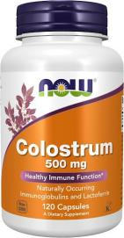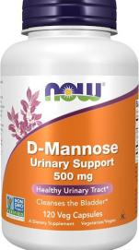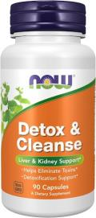

NOW foods supplement, l-lysine hydrochloride 1000mg, double strength, amino acid, 100ct

# 246.26

NOW food supplements, alpha lipoic acid 250mg , supports glutathione production, free radical scavenger, 60 veg capsules

302.08

NOW foods supplements, colostrum 500mg naturally occurring immunoglobulins and lactoferrin, 120 veg capsules

300.11

NOW foods supplements-Mannose 500mg , Non-GMO Project verified , healthy urinary tract, 120 veg capsules

# 414.71

NOW foods supplements, detox and cleanse 90 veg capsules, liver and kidney support

307.76

NOW foods supplements, evening primrose oil 500mg ,100 soft gels

182.53

NOW food supplement kidney cleanse with Uva Ursi, parsley seed, fennel, and horsetail, 90 veg capsule

290.90

NOW foods supplements magnesium glycinate 100mg, highly absorbable form, 180 tablets

# 417.92

NOW food supplements, Melatonin 5mg 120 tablets

225.26

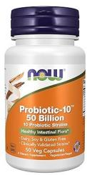Now foods supplements, probiotic-10TH , 25billion with 10 probiotics strains, dairy, soy and gluten free , strain verified ,100 veg capsules

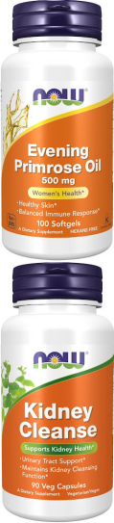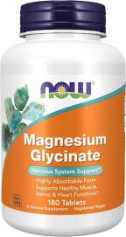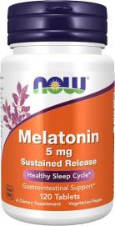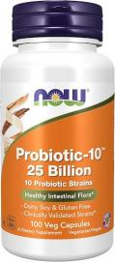

NOW foods supplements, probitic-10TH ,50 billion ,with 10 probiotic strains ,50 veg capsules

# 465.10

582.18

NOW foods supplements, prostate support, with standardized saw palmetto, stinging nettle & lycopene, 90 soft gels

# 421.88

NOW foods supplements, psyllium husk caps 500mg, intestinal health ,200 veg caps

# 246.75

NOW food supplements, super primrose 1300mg with naturally occurring GLA ,60 soft gel

300.35

NOW foods supplements, women’s probiotic ,20 billion 50veg caps400.88

NOW foods supplements, zinc (zinc Gluconate) 50mg 100 tablets

# 127.45

NOW foods, B-1 100mg ,100tabs 135.85

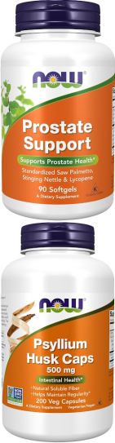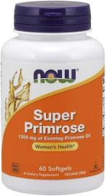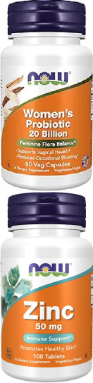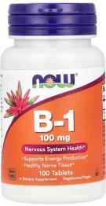

NOW foods, cinnamon bark, 600mg 120 veg caps

# 241.81

NOW foods, folic acid 800mg with vitamin B12 250tablets

150.92

NOW foods inositol powder 4oz 351.73

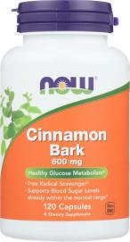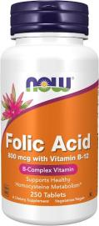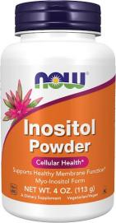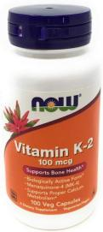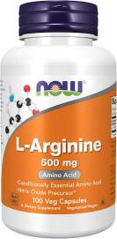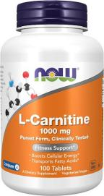

Now foods, K-2 100mg, 100 Caps 244.78

NOW foods L- Arginine, 500mg 100veg capsules 196.37

NOW foods,L-Carnitine ,1000mg 100tablets 688.88

NOW foods, L-Glutamine, amino acid 500mg ,120 vegs

# 241.81

NOW foods, L-Lysine, 500mg, 100 tablets 185.25

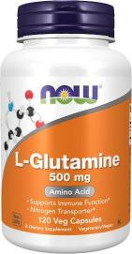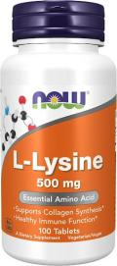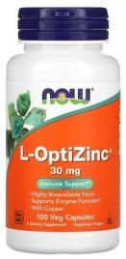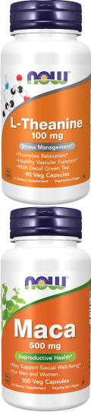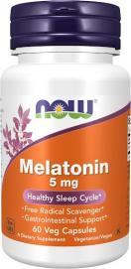

NOW foods, L-Opti Zinc ,30mg ,copper 0.3mg 100veg caps

181.05

NOW foods, L-theanine ,100mg ,90 veg caps 266.02

NOW ffoods, Maca, 500 mg, 100 Veg Caps 196.37

NOW foods, melatonin, 5mg 60 veg caps 135.85

NOW food, menopause support 90 veg caps 332.46

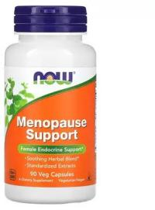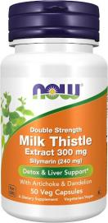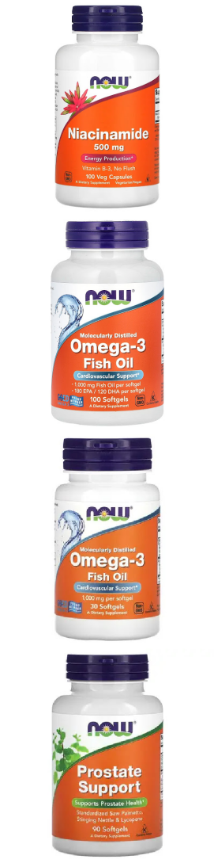

NOW foods milk thistle, double strength, 300mg 50veg caps

190.19

NOW foods, niacinamide, vitamin B3 ,500mg 100 veg caps

181.05

NOW foods, Omega -3 fish oil, 1000mg 180 epa-120 Dha, 100 soft gels

196.37

NOW foods, Omega-3 Fish oil 1000mg ,30 soft gels

# 90.40

NOW foods, prostate support ,90 soft gel 421.88

NOW foods, selenium 100mcg ,100 tabs 120.54

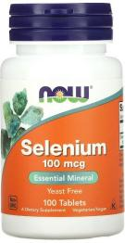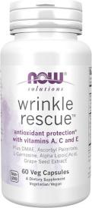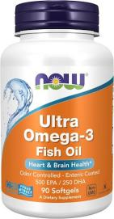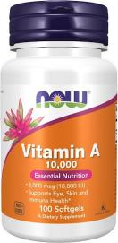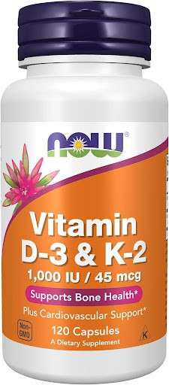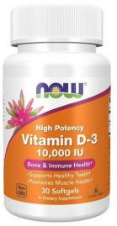

Now foods, Wrinkle RescueTM, caps, targeted blend with vit A,C and E 60 caps

328.51

NOW foods Ultra Omega-3 Fish oil, 90 soft gel 353.70

NOW foods Vit A ,10000 IU , 100 soft gel 108.43

NOW foods Vit D-3& K-2, 120 veg caps 226.50

NOW foods, Vit D-3, high potency, 10000 IU, 3o soft gel

# 120.54

NOW foods, VitaminD-3, High potency ,5000 IU, 30 soft gel

# 90.40

NOW foods, Zinc Glycinate, 30mg Zinc 120 soft gel 271.95

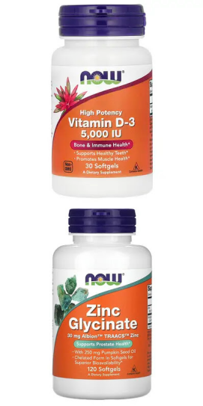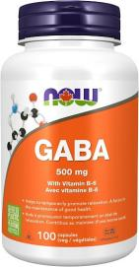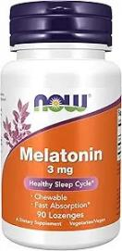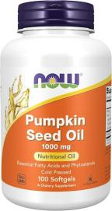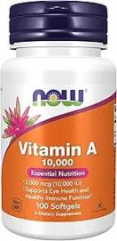

NOW Gaba 500mg 100 veg caps 202.54

NOW foods, Melatonin 3mg, Free Radical scavenger, healthy sleep cycle 90chewable lozenges

# 105.47

NOW foods, Pumpkin Seed oil 1000mg, Cold pressed ,100 soft gel

261.57

NOW foods, Vit A 10 000 IU, 100 soft gel

197.35

NOW food, Vit D-3, K-2 ,1000IU/45mcg, plus cardiovascular support, 120 veg capsule

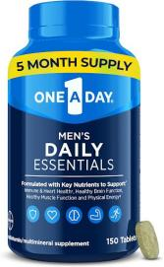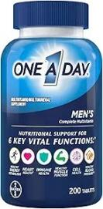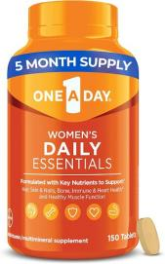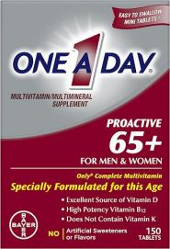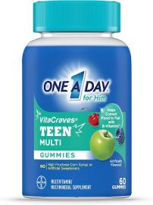

# 228.48

One A Day Men’s multivitamin daily Essentials, 150 count

# 478.93

One A Day Men’s multivitamin daily Essentials, 200 count

# 419.65

One A Day women’s multivitamin daily Essentials, 150count

# 478.93

One A Day Proactive 65+, Men & Women multivitamin, 150 count

271.21

One A Day Teen for Him multivitamin Gummies, 60 count

# 246.51

One A Day Women’s 50+ multivitamin, 200 count

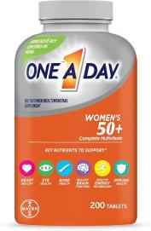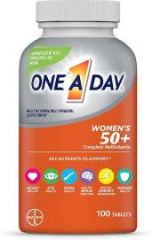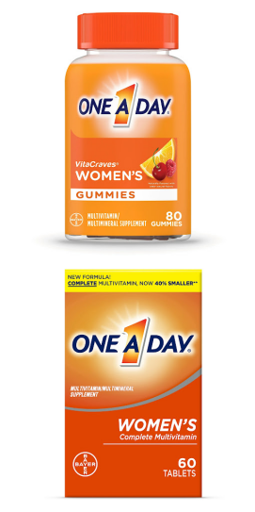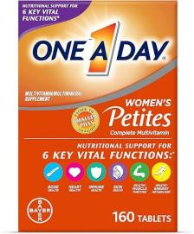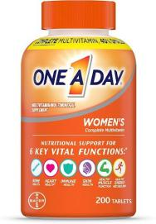

502.65

One A Day Women’s 50+ Multivitamins, Calcium & more 100 counts

336.66

One A Day Women’s gummy Multivitamins ,80 count

# 246.51

One A Day Women’s multivitamin with Vit A, C, D and E 60ct

197.11

One A Day Women’s Petites Multiviitamin, 160 count

# 305.54

One A Day woman’s complete daily multivitamin,200 CT

# 419.65

Opcon-A allergy Eye drops by Bausch + Lomb 0.5Fl Oz

# 141.53

Orajel 3x for toothache & gum pain, Maximum gel tube 0.42oz

# 124.49

Oxy Acne cleaner maximum Strength ,5.0 Fl Oz 192.91

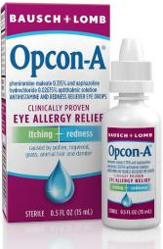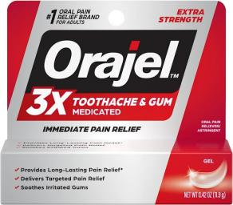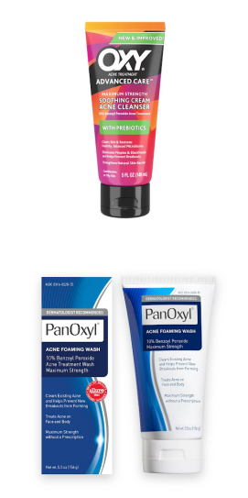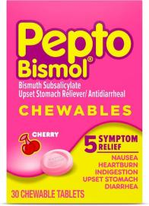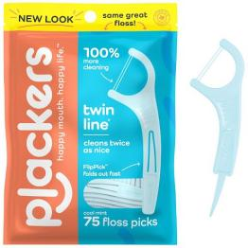

PanOxyl acne foaming wash benzoyl peroxide 10% maximum strength antimicrobial,5.5Oz

# 231.44

Pepto Bismol chewable , upset stomach relief , indigestion,Diarrhea ,cherry Flavors ,30tablet

# 114.61

Placker twin - line dental floss picks ,75 count 62.49

Polident overnight whitening denture cleanser tablets ,120count

117.33

Polident overnight whitening denture cleanser tablets ,84count

127.21

Puritan’s pride premium cranberry fruit concentrate 84mg (4200mg equivalent) with vitamin C and E, 250 rapid release soft gel

296.65

Puritan’s pride QoQ10 100MG 60ct 313.94

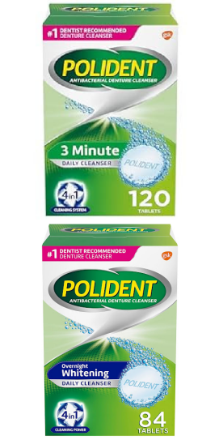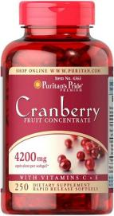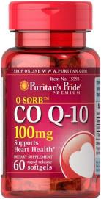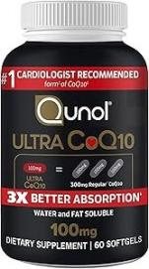

Qunol ultra CoQ10 100mg soft gels 443.61

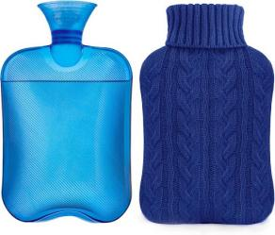Samply hot water bottles with knitted cover ,2L

293.68

Simpli supplements 60 boric acid suppositories 246.51

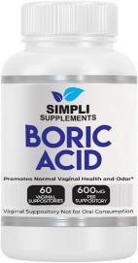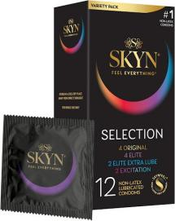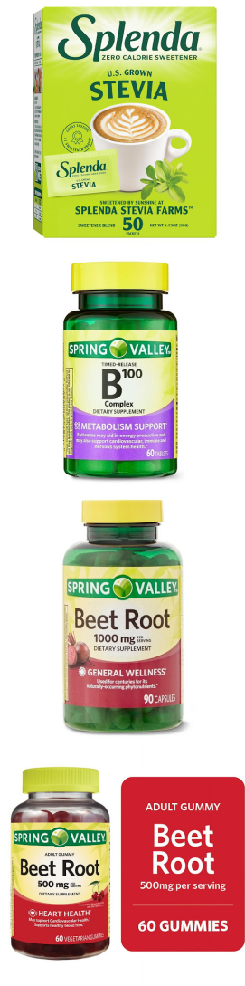

SKYN selection non-latex condoms 12 count 213.16

SPLENDA stevia zero calorie sweetener, sugar substitute packets ,50 count

80.28

Spring Valley B-100 complex metabolism supports dietary supplement timed – release tablets ,60 count

# 146.72

Spring Valley Beet root dietary supplement, 1000mg 90 count

# 219.34

Spring Valley beetroot dietary supplement gummies, cherry 500mg ,60count

# 245.52

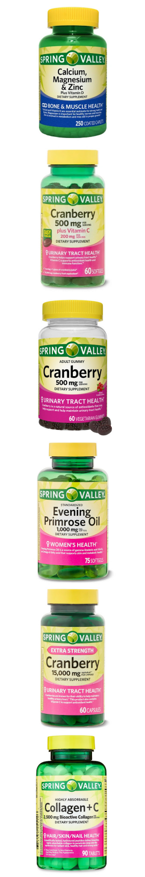Spring Valley calcium, magnesium & zinc plus vitamin D3 coated caplets 250 ct

Spring Valley cranberry dietary supplement soft gels 500mg 60counts

Spring Valley cranberry gummies dietary supplement 500mg ,60 count

Spring Valley evening primrose oil women’s health dietary supplement soft gels ,1000mg , 75 counts

Spring Valley extra strength cranberry dietary supplement capsules ,15, 000mg 60counts

Spring Valley highly absorbable collagen + C tablets for hair /skin /nail health, 2500mg ,90ct

183.77

195.87

231.69

# 169.94

219.34

213.90

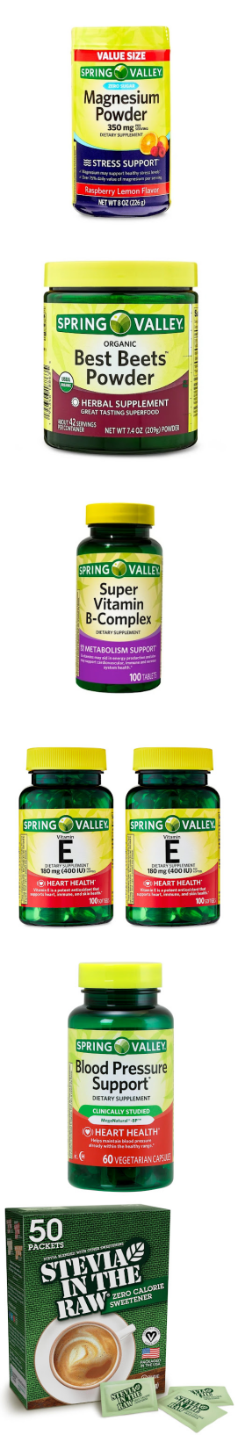Spring Valley Magnesium stress support dietary supplement Powder, Raspberry lemon flavor

Spring Valley Organic best beet powder 7.4 oz 290g

Spring Valley super Vit B – complex tabs ,100 counts

Spring Valley Vitamin E dietary supplement Twin pack 180mg, 200caps

Spring Valley Blood pressure support ,60 vegetarian capsules

Stevia in the Raw, plant based zero calories sweetener, sugar substitute, vegan, gluten -free, 50 count packets

# 268.74

288.50

97.81

# 184.76

244.04

123.25

Systane Ultra lubricant eye drops, 0.14 Fl oz 142.03

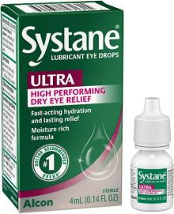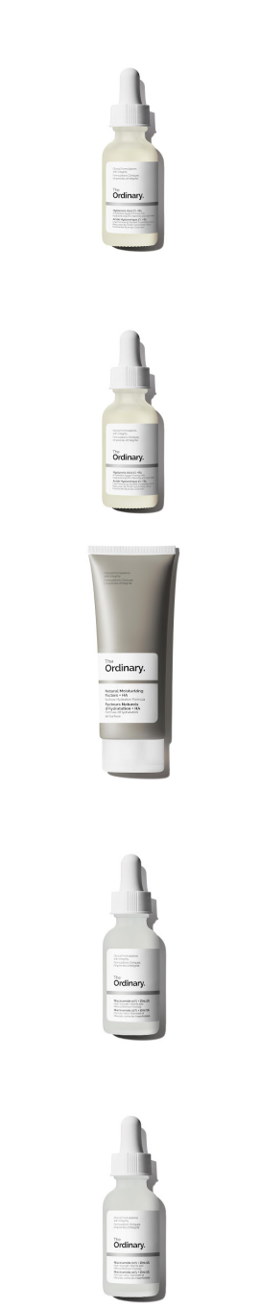

The Ordinary hyaluronic Acid 2% + B5, Multi-Depth Hydration serum for Plumper, smoother Skin

257.87

The Ordinary Hyaluronic Acid 2% + B5, multi- Depth Hydration serum for plumper, smoother skin

257.87

The Ordinary Natural Moisturizing factors + HA 345.80

The Ordinary Niacinamide 10% + Zinc 1% smoothing Serum for Blemish -prone skin 148.20

The Ordinary Niacinamide 10% + Zinc 1% smoothing serum for blemish -prone skin

# 148.20

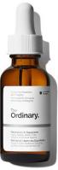The Ordinary retinol 1% in squalane, High-strength retinol

Serum for anti-aging and skin smoothing

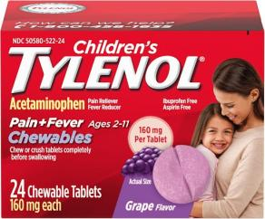Tylenol children’s chewable with 160mg Acetaminophen , pain reliever ,24cts

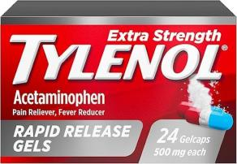Tylenol Extra strength acetaminophen rapid release gels, gelcaps with laser drilled holes ,500mg ,24ct

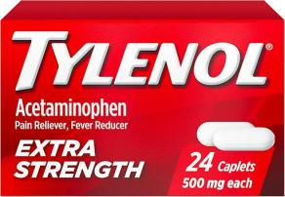Tylenol extra strength caplets with 500mg acetaminophen, pain reliever & fever reducer, 24 ct

298.62

# 147.95

118.07

# 110.41

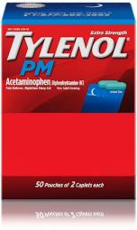Tylenol Pm extra strength 50 packs of 2 caplets 397.18

Tylenol Pm extra strength Pain reliever & sleep Aid caplets 500mg Acetaminophen 24ct

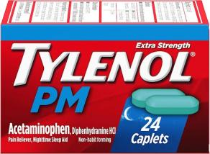129.97

Vagisil anti-itch medicated femine intimate wipes for women , 12 wipes

105.22

Visine multi-symptom eye drops -astringent, lubricant & redness reliever for irritated, dry, red eyes 0.5 ﬂ. oz

162.53

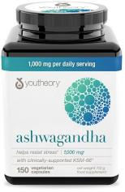fast -acting Wart Remover -Effective plantar and genital Wart removal with natural ingredients – Attacks warts on contact, easy dropper application ,1 ﬂ oz

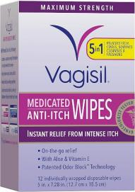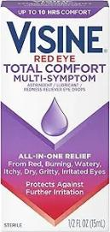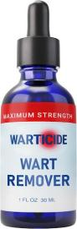

Youtheory ashwagandha 1000mg vegetarian capsules 150ct

You theory B12 B6- vegan Vitamin B6 & vitamin B12 1000mcg ,60 vegetarian capsules

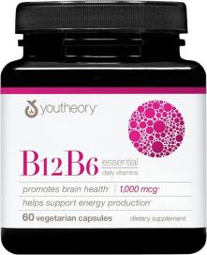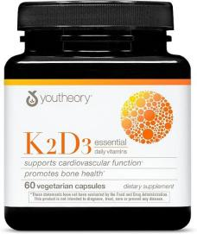

# 411.26

445.09

236.87

Youtheory K2D3 – bone & heart health support 60 vegetarian capsules

276.39

Youtheory Men’s collagen -5000mg collagen -daily supplement for men

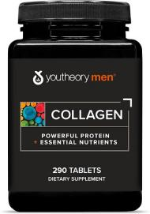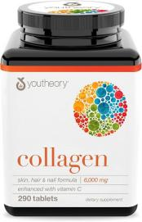

# 481.65

Youtheory collagen with Vitamin C , 290 supplements

485.60